**Group Reflection**

Kim Ve Jong:

Since forming our team over a month ago in early December, we have had collaboration ever since using the Discord software. The group has been really supportive and we have delegated our work appropriately with each member contributing each section of work. My responsibilities include creating the Github repository and regulate the repository, and the report on Industry Data with Burning Glass. I have worked with everybody’s bio from assignment 1 and incorporated into our assignment 2’s bio. Now, some of the members in our group work full time and in my case, I work in the afternoon shift and sometimes cannot chat in the evening session. However, when I got home around 2am, I quickly attend the task the group has set out earlier and they usually respond in the morning. The team also adjusted and included collaborating during the morning as well. So, by around Christmas we had an active channel and typed regularly throughout the day to get the latest update including the update on Github. With an additional member being David that recently joined our group, he has quickly settled in our group and took responsibility for his share of the work. Samuel Jones has played a crucial role in our group and has shown leadership amongst the group and have been quite active in updating the Github repository. Below is a snapshop in our updates on Github files and documents.

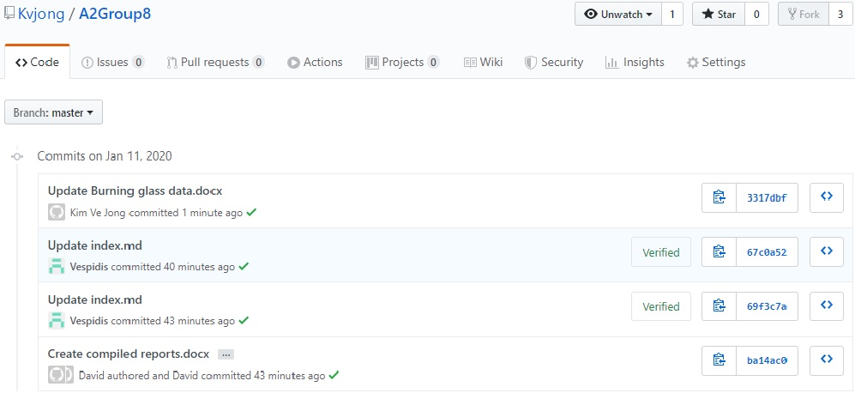

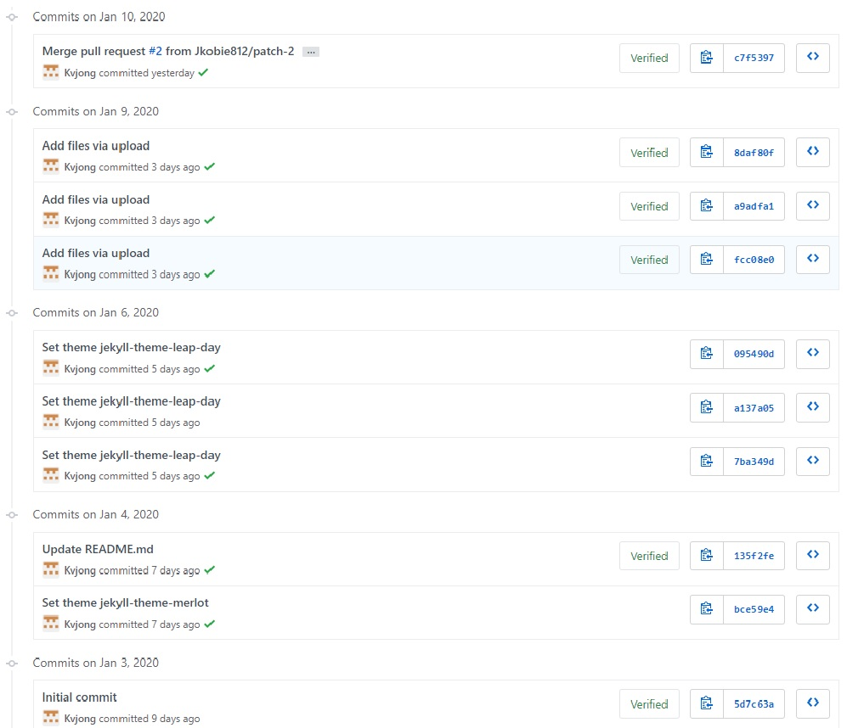

David Mulgrue:

This group assessment has been fraught with difficulties which thankfully have all ended up being resolved at the last moment.

My first group seemed to be working well, but due to some miscommunication over the holiday period I ended up being removed from the group and placed in an auto assigned one.

I made multiple attempts to make contact with the members of this group but was unsuccessful, in the end I managed to make contact with a group who had open space and could use an extra person to help with some reports and polish some of the documentation, which I was more than happy to do.

I’ve found that while this group has had some relatively small communication problems, the quality of the work has been excellent and I have had no issues with slotting myself in and compiling the work and adding my own to make a complete and comprehensive set of reports.

Scott Smith:

I have worked in many teams in my career, made up of people from various backgrounds and cultures. This is the first time that I have worked in a team of people that I haven’t met. As we are only a couple of days out from submission date, overall, I feel that our team has worked quite well together. We were off to a “shaky” start due to the Christmas period and most of us working different jobs, particularly those that work in a shift work environment.

We initially tried to do voice discord chats, that didn’t work out well due to the aforementioned reasons. So, we ended up using Discord text chat which was a far better solution, people could reply when they had a chance. Once we had our communication sorted, tasks were assigned, and we were able work within our own time for overall compilation later. We could have improved by communicating earlier.

Once thing that was surprising (but not bad) we had a new member join our team only 6 days out from submission. The member was having problems communicating with his own team, so we felt we were in a position to help him.

One thing about groups, every person has their own ‘pros and cons’ communication is key. You can’t rush things, everyone has their own busy schedule.

Below is a snapshot of our group’s activity in Github:

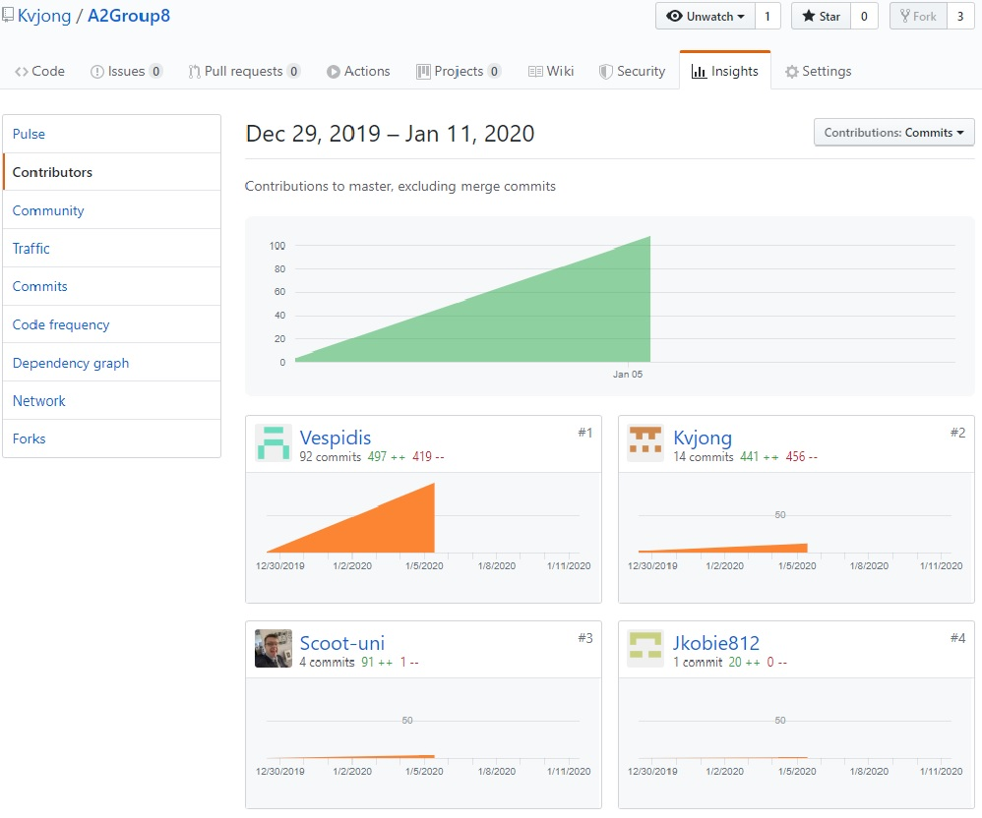

Below is a snapshot of our group chat in Discord. We have two channels and have been communicating on a daily basis since before Christmas.

